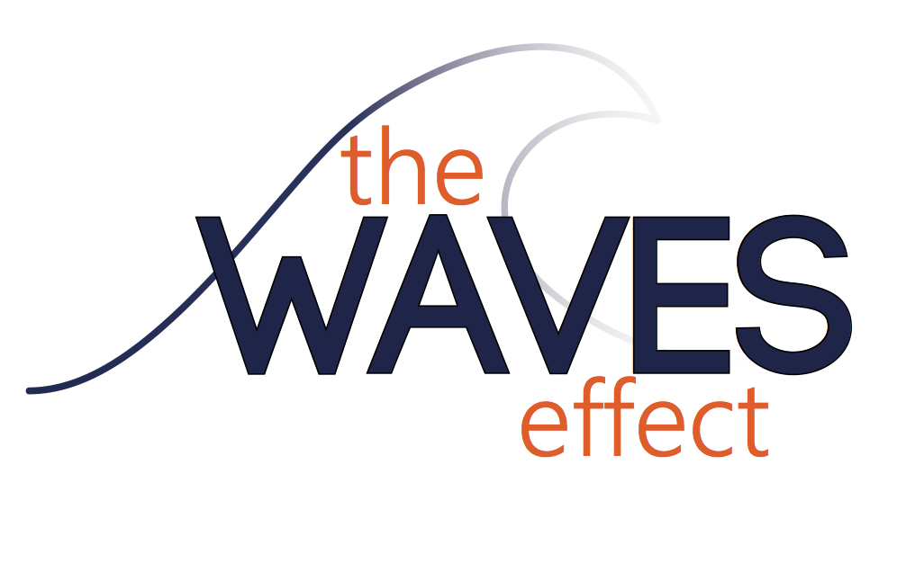

The Waves Effect is a fully integrated, student-run communications agency dedicated to building
creative, strategic and effective campaigns that meet the professional needs of our clients.
New Member Application

Name:

Email: Phone:

Local address/ Box number:

Class: Freshman
Sophomore
Junior
Senior
Graduate student

Major: Minor (optional):

Cumulative GPA: Major GPA:

Please explain your interest in joining The Waves Effect.

What relevant courses have you completed?

What relevant past experience do you have?

What do you hope to gain from working with The Waves Effect?

Please list other extracurricular activities and time commitments (e.g., jobs, internships, student organizations, etc.):

Position desired: Advertising Director:
Public Relations Director:
Media Director:
Advertising Coordinator:
Public Relations Coordinator:
Media Coordinator:
Reference (current Pepperdine University professor)
Name: Email Address:

Please email this application and your resume to thewaveseffect@gmail.com

Thank you for your interest in joining The Waves Effect team.

